Sight Vocabulary

👁️‍🗨️ What is Sight Vocabulary
# Source: Chatgpt (GPT-4-turbo) at [7/30/2025]
Sight vocabulary refers to words that a person can recognize and read instantly, without needing to sound them out or analyze them. These are typically high-frequency words and are critical for fluent reading, especially in early literacy development.

✅ Key Features:
# Source: Chatgpt (GPT-4-turbo) at [7/30/2025]
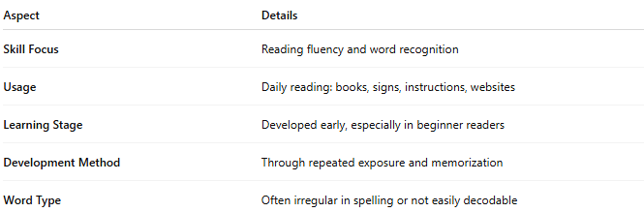
Aspect | Details
Skill Focus | Reading fluency and word recognition
Usage | Daily reading: books, signs, instructions, websites
Learning Stage | Developed early, especially in beginner readers
Development Method | Through repeated exposure and memorization
Word Type | Often irregular in spelling or not easily decodable

🧠 Examples:
# Source: Chatgpt (GPT-4-turbo) at [7/30/2025]
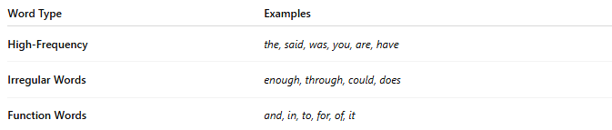
Word Type | Examples
High-Frequency | the, said, was, you, are, have
Irregular Words | enough, through, could, does
Function Words | and, in, to, for, of, it
📌 Many sight words come from Dolch or Fry word lists, used in early reading instruction.

👤 Who Uses It?
# Source: Chatgpt (GPT-4-turbo) at [7/30/2025]
- Young readers (especially K–3)
- Struggling readers
- ESL learners
- Educators and reading specialists

📌 Related Vocabulary Types:
# Source: Chatgpt (GPT-4-turbo) at [7/30/2025]
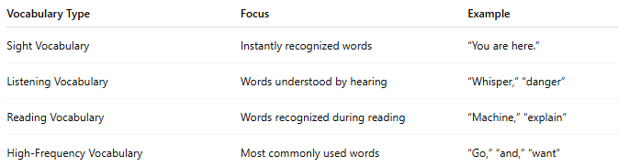
Vocabulary Type | Focus | Example
Sight Vocabulary | Instantly recognized words | “You are here.”
Listening Vocabulary | Words understood by hearing | “Whisper,” “danger”
Reading Vocabulary | Words recognized during reading | “Machine,” “explain”
High-Frequency Vocabulary | Most commonly used words | “Go,” “and,” “want”

